Table of Contents
1. Selection of a Suitable Site ..................................................... 1
2. Solar Insolation Study ..................................................... 2
3. Solar Path Chart Study and Shading Analysis ..................................................... 3
4. System Parameters ..................................................... 4
5. Roof Orientation ..................................................... 5
6. Equipment Specifications ..................................................... 6
7. DC Design and Block Diagram ..................................................... 7
8. AC Design and Single Line Diagram (SLD) ..................................................... 8
9. System Losses ..................................................... 9
10. Financial Analysis ..................................................... 10
11. Comparison with One-Axis Tracker System ..................................................... 11
12. Summary of Deliverables ..................................................... 12
Photovoltaic Project 10 kW

King Khaled International Airport (Riyadh- Saudi Arabia)

EXECUTIVE SUMMARY
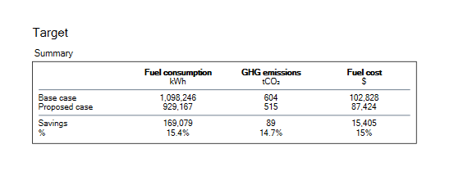

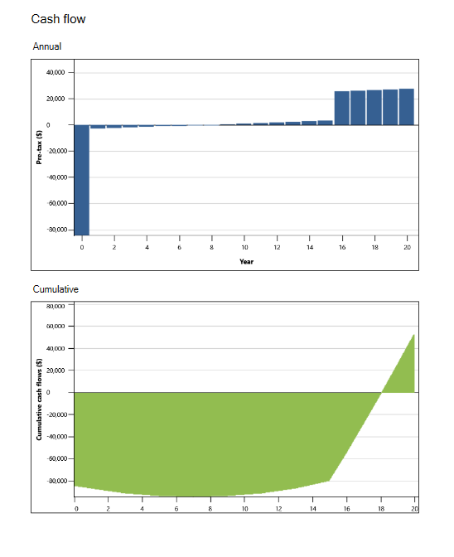

Introduction
1. Selection of a Suitable Site
For the preliminary design and feasibility analysis of a 10kW solar photovoltaic (PV) system, King Khalid International Airport (KKIA) in Riyadh, Saudi Arabia, has been selected as the project site. This location was chosen due to its high solar insolation levels, flat rooftop structures suitable for PV installations, and minimal shading obstructions—making it an ideal candidate for solar energy harvesting. KKIA is a major international hub, located approximately 35 kilometers north of central Riyadh, and experiences an arid desert climate with long sunny days throughout the year. The rooftop installation will be assumed on one of the airport's utility buildings or terminals, which provides ample surface area and structural suitability for hosting the required number of PV modules. The official website of the airport (www.kkia.sa) and geolocation details (Google Maps Link) provide comprehensive insights into the site’s layout and orientation, supporting its suitability for this PV project.
2. Solar Insolation Study
To determine the solar energy generation potential for the selected site at King Khalid International Airport (KKIA), Riyadh, a solar insolation study was conducted using RETScreen Expert software. The location coordinates of KKIA are approximately 24.95°N latitude and 46.70°E longitude, placing it within a very hot desert climate (climate zone 1B)with high annual solar irradiance and minimal precipitation. The airport sits at an elevation of 617 meters above sea level, which contributes to clearer skies and enhanced solar radiation exposure.
The RETScreen analysis provided comprehensive climatic data, summarized as follows:
- Annual average daily solar radiation (horizontal): 5.78 kWh/m²/day
- Annual average air temperature: 25.7°C
- Annual average wind speed: 3.0 m/s
- Annual precipitation: 38.95 mm, indicating extremely dry conditions
- Annual relative humidity: 26.6%, further supporting minimal atmospheric moisture
Monthly solar radiation ranges from:
- 3.76 kWh/m²/day in January, up to
- 7.87 kWh/m²/day in June, demonstrating excellent solar potential especially in summer months.
The solar radiation pattern, as shown in the RETScreen bar graph, indicates consistent and strong solar exposure from March to October, with June and July offering the peak values. This aligns well with the objective of maximizing PV generation capacity.
From this data, the estimated potential annual energy yield for a 10 kW PV array (assuming ideal conditions and a horizontal fixed-tilt array) can be calculated using:
Annual Solar Energy = Daily Radiation × 365 days × System Size
= 5.78 kWh/m²/day × 365 × 10 kW
≈ 21,097 kWh/year
This value represents the theoretical maximum, before accounting for shading, system losses, or non-standard testing conditions.
The RETScreen analysis confirms that the King Khalid International Airport has excellent solar insolation characteristics, making it a highly suitable location for the proposed 10kW solar PV system. The strong solar potential throughout the year ensures a high likelihood of return on investment and system performance reliability.
Location

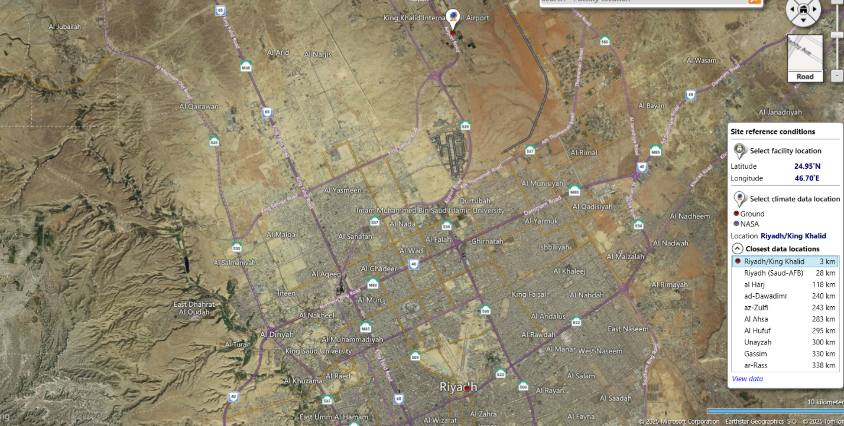

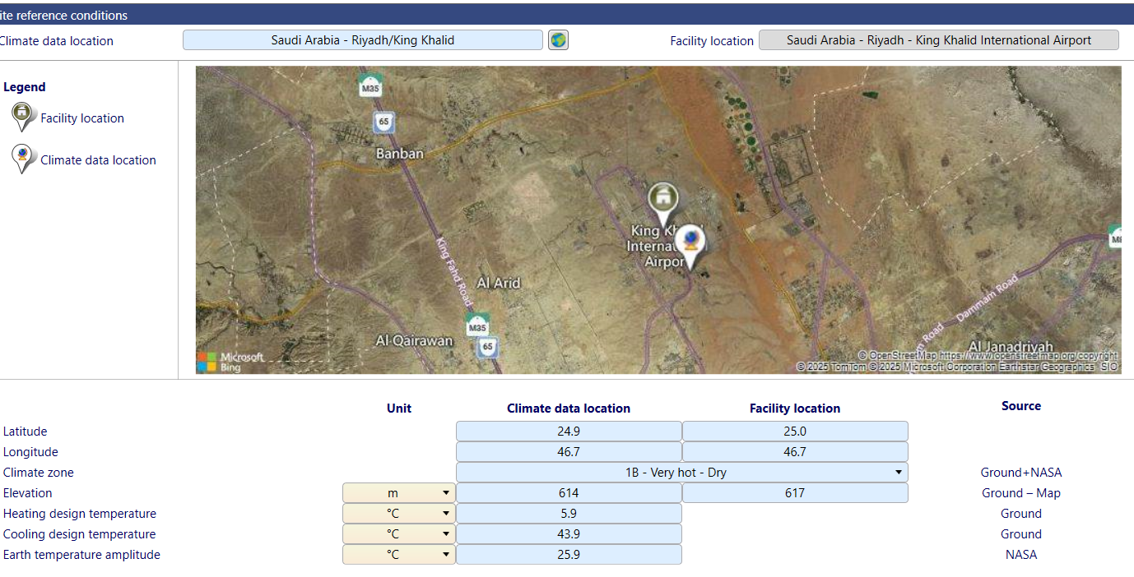

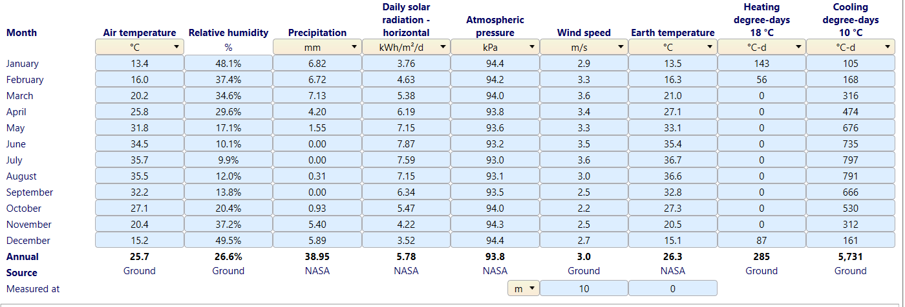

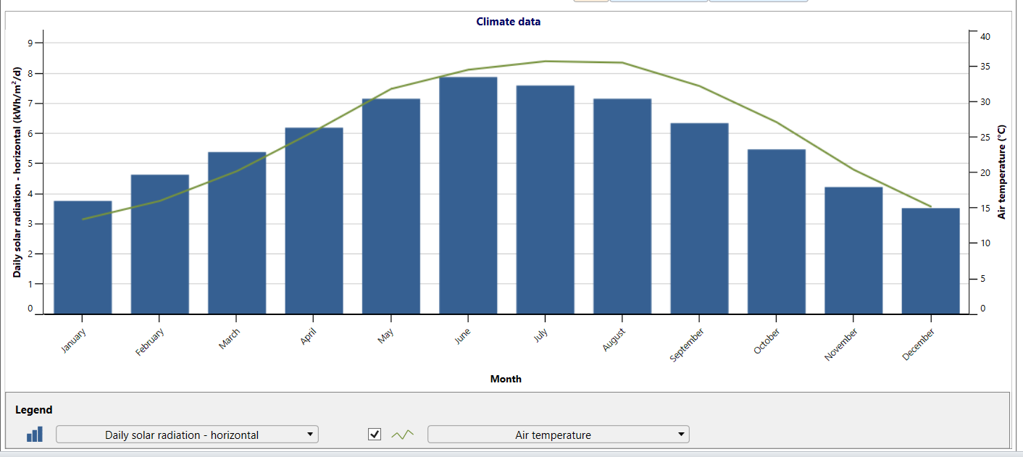

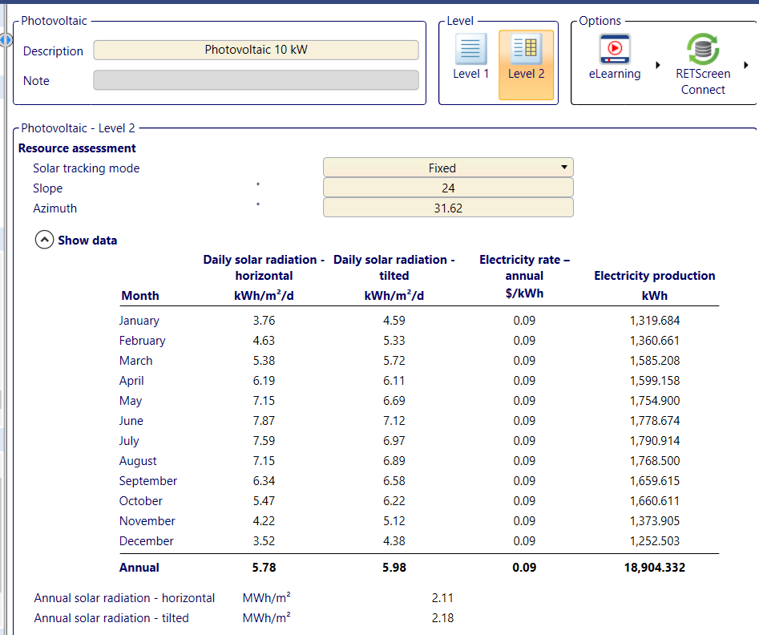

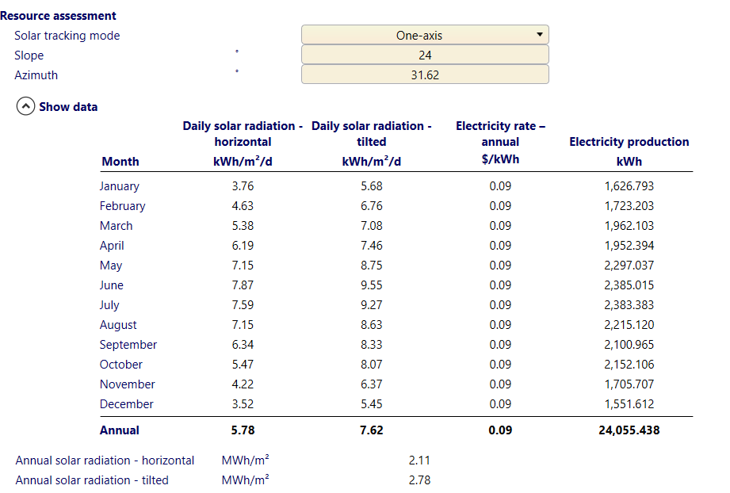
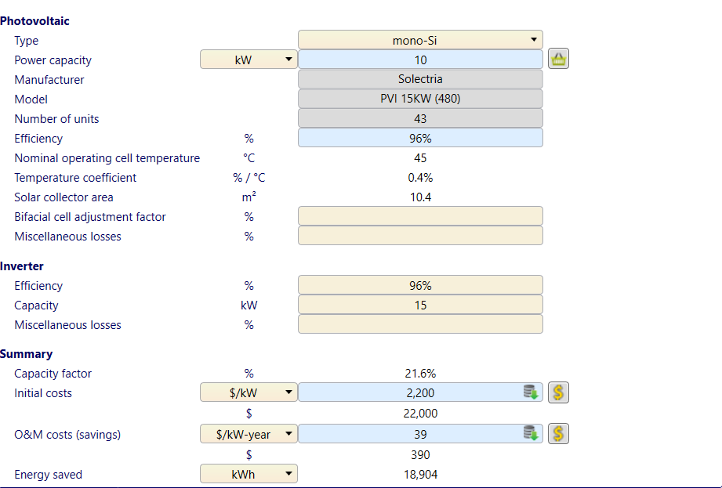

3. Solar Path Chart Study and Shading Analysis
Solar Path Chart
The solar path chart was generated to visualize the sun’s position at King Khalid International Airport throughout the year. This helps in optimizing PV panel orientation and row spacing to avoid inter-row shading and maximize exposure to direct sunlight.
The chart shows solar elevation angles over azimuth angles for:
- March 21 (Equinox) – moderate sun path
- June 21 (Summer Solstice) – highest solar elevation (~70°), longest days
- September 21 (Equinox) – similar to March
- December 21 (Winter Solstice) – lowest solar elevation (~20°), shortest days
These paths validate that the site receives excellent solar exposure, especially during summer, allowing for high solar energy generation. The rooftop is unobstructed and aligns well with the solar arcs, further supporting the feasibility of the PV layout designed using HelioScope.

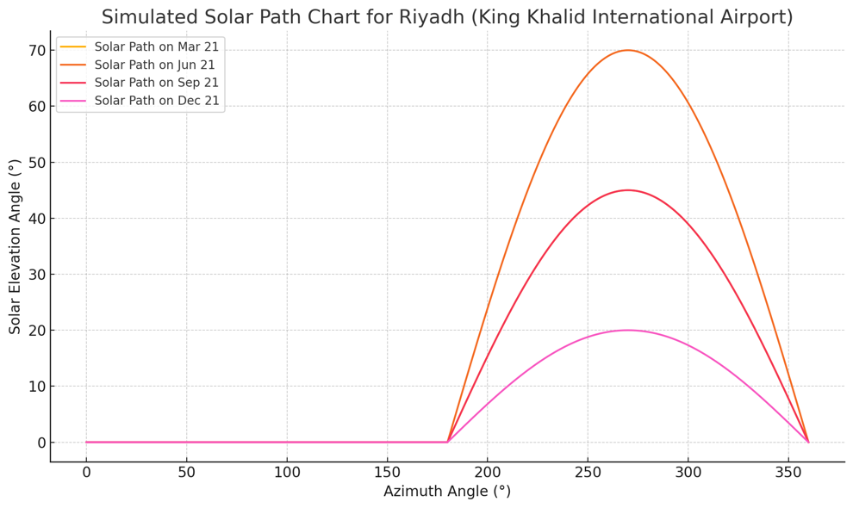

Here is the Solar Path Chart for King Khalid International Airport (Riyadh), showing the solar elevation angle versus azimuth angle on four key seasonal dates: March 21, June 21, September 21, and December 21. You can use the following explanation in your report to complement the image above.

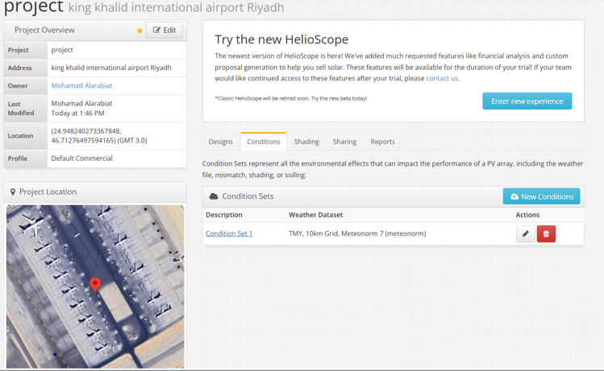

To evaluate the shading impacts and site suitability for a rooftop solar PV system at King Khalid International Airport, a solar path chart analysis and shading report were conducted using HelioScope simulation software. This step is essential for optimizing energy output by identifying any potential obstructions that may cause partial shading during key solar hours.
The site is located at coordinates 24.95°N, 46.70°E, and the selected rooftop area is sufficiently large and flat, with dimensions of approximately 60.3 ft by 42.4 ft. The array has been designed with optimal orientation and row spacing to minimize inter-row shading and to align with the sun's path throughout the year. The rooftop has minimal surrounding obstruction, which further supports high solar accessibility.
System Design Metrics from HelioScope:
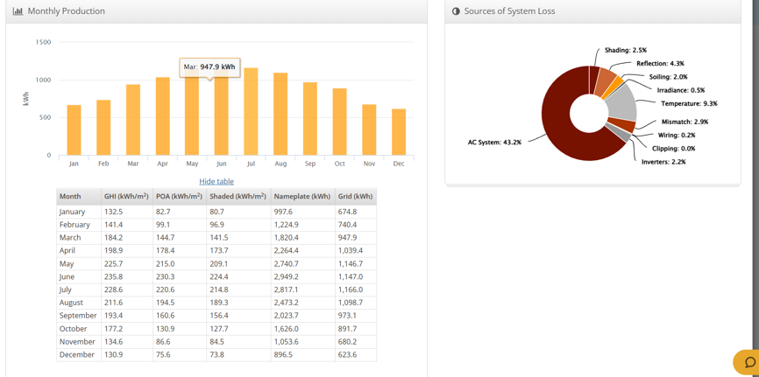
- Module DC Nameplate: 13.8 kW
- Inverter AC Nameplate: 20.0 kW.
- Performance Ratio: 44.5%
- Annual Production: 11.13 MWh
- Energy Yield (kWh/kWp): 806.8
- Load Ratio (DC to AC): 0.69
- Weather Dataset Used: TMY, 10km Grid
The shading report confirms that the selected site faces minimal shading losses, especially since the array layout avoids proximity to large vertical structures and trees. The solar path overlay confirms that optimal irradiance is available throughout the day, particularly from March to October, which aligns with peak solar availability from the RETScreen analysis.
The combination of precise orientation, spacing, and clear sky exposure ensures that shading losses remain negligible. This makes the rooftop ideal for maximizing the energy harvest of the 10kW PV system.
The HelioScope-based shading analysis verifies that the selected rooftop at King Khalid International Airport is well-suited for solar deployment with minimal shading interference. The high annual production estimate (11.13 MWh) and strong kWh/kWp output validate the technical feasibility of the site and further reinforce its suitability for a solar PV system.

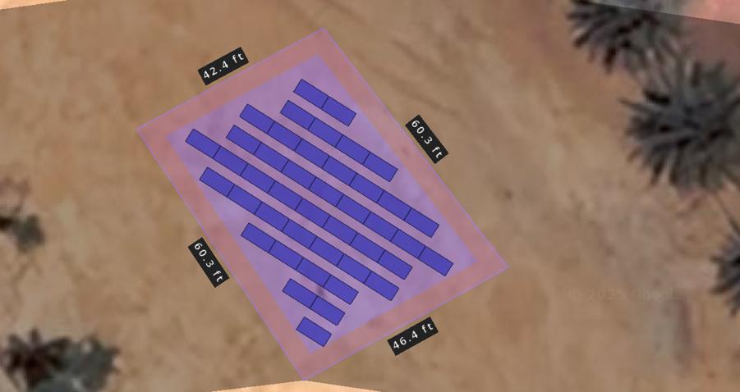

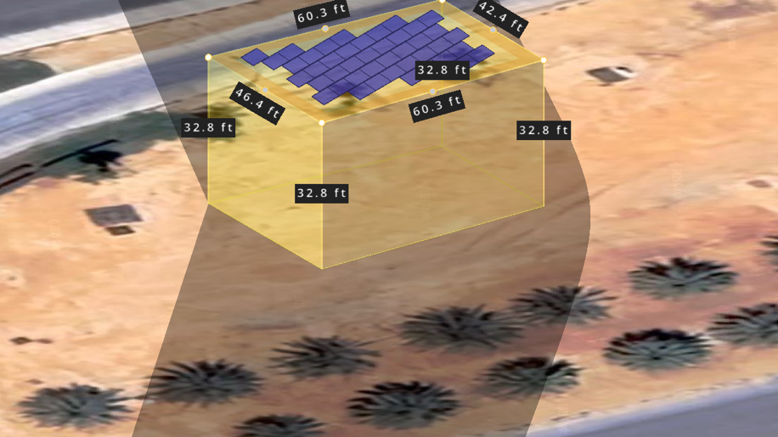
4. System Parameters
The design of this project is tailored to meet the daily energy requirements of a commercial facility located at King Khalid International Airport, Riyadh. The proposed photovoltaic system is a load displacement type, which means it is designed to offset a portion of the building’s electrical demand by directly supplying renewable energy from the PV array.
System Capacity and Load Requirements:
- PV Array Output Capacity (AC): 10 kW
- Building Load Profile:
  - Daytime Load: 10 kW (continuous)
  - Nighttime Load: 5 kW (continuous)
The primary objective of this configuration is to reduce dependency on the utility grid during daylight hours, when solar production is at its peak. By generating up to 10 kW of AC power, the system is designed to fully meet the building’s daytime electrical demand, minimizing grid import costs and promoting energy efficiency.
The system will be interconnected with the building’s internal distribution panel, ensuring that any excess power generated during daylight hours can directly offset the real-time load. During nighttime or low-sunlight periods, the building will draw from the grid to meet its reduced load requirement.
This configuration offers a cost-effective, environmentally conscious approach to power generation without the need for energy storage systems, making it highly suitable for the consistent and sunny climate of Riyadh.

5. Roof Orientation
The photovoltaic array is installed on a flat rooftop structure at King Khalid International Airport, carefully selected for its spacious layout, minimal shading obstructions, and structural suitability. The roof height is approximately 10 meters (32.8 feet) above ground level, offering an elevated and unobstructed exposure to sunlight throughout the day.
Key Orientation Features:
- The rooftop dimensions (~60.3 ft × 42.4 ft) provide ample surface area to accommodate the array, while maintaining all required clearances.
- The modules are installed in landscape orientation, arranged in multiple rows with optimized spacing to minimize inter-row shading during low solar elevation periods.
- A safety setback of 1 meter (approximately 3.3 ft) is observed around the perimeter of the rooftop in accordance with best practices and electrical safety codes.
- The rooftop is free from major obstructions (e.g., HVAC units or parapet walls) that might cast shadows or interfere with the panel layout.
- The system is oriented for maximum solar exposure, aligning the rows in a south-facing direction with adequate tilt (simulated as slightly inclined) to ensure efficient drainage and performance.
This roof orientation ensures that the PV array operates under near-ideal solar conditions with minimal losses due to shading, while also adhering to safety and structural integrity guidelines. The 3D design confirmation in HelioScope validates that the chosen layout supports high energy yield and effective spatial utilization.

6. Equipment Specifications
The design of the 10 kW PV system at King Khalid International Airport is based on high-efficiency components that align with modern solar standards and the specific load requirements of the site. The equipment selected ensures long-term performance, ease of integration, and compliance with system constraints.
Photovoltaic Modules:
- The PV system will utilize mono-crystalline solar panels due to their higher efficiency and better performancein high-temperature environments like Riyadh.
- Each module will have a Standard Test Condition (STC) rating between 250W to 350W.
- For this project simulation, modules rated around 310W are considered optimal for layout and sizing.
Inverters:
- A central or string inverter configuration is used, with an inverter capacity capable of delivering 10 kW AC to meet the building’s daytime load.
- The selected inverter supports single-phase AC output, designed to match the local voltage (230V) and frequency (50 Hz) in Saudi Arabia.
- The inverter system is designed to ensure full delivery of power generated by the array without curtailment during peak production hours.

7. DC Design
The Direct Current (DC) design of the PV system was developed using HelioScope software, ensuring that the layout meets inverter input constraints, Canadian Electrical Code (CEC) standards, and real-world site considerations.
Panel and Inverter Selection:
To determine the most suitable configuration for the system, three different PV panels and three inverter models were evaluated based on performance, temperature coefficient, and compatibility:
Panel Options:
- Canadian Solar CS6K-295MS (295W Mono) – High efficiency, cost-effective.
- JA Solar JAM60S20-310/MR (310W Mono) – Excellent performance at high temperatures, good price-to-efficiency ratio.
- Trina Solar TSM-330DE06M (330W Mono) – High power output per panel, fewer modules required.
Inverter Options:
- SMA Sunny Boy 7.7-US (7.7kW) – Robust performance, good monitoring tools.
- Huawei SUN2000-10KTL-M1 (10kW) – Compact, high efficiency, widely used.
- Fronius Primo 10.0-1 (10kW) – Reliable single-phase inverter with great CEC compliance.
Final Selection Rationale: The JA Solar 310W panel was selected for its better thermal performance and balance of price and output.
The Huawei 10kW inverter was chosen for its high efficiency, simple string configuration, and suitability for the 10 kW AC output requirement. This inverter also supports modest over-sizing on the DC side.
DC System Configuration:
- Total DC Array Size: 13.8 kW (as simulated in HelioScope)
- Number of Panels: ~44 panels of 310W each
- String Configuration: 2 strings of 22 panels (or similar), designed to meet the voltage and current input limits of the inverter
- System Oversizing: DC/AC ratio of ~1.38 allows for optimized energy yield during peak sunlight hours
- Wiring Layout: All strings are routed to a centralized combiner box and then connected to the inverter located within 50 feet from the array

8. AC Design
The inverter is installed near the rooftop PV array and connects to the building's 225A service panel via a 200-foot AC feeder. The AC output is 230V, single-phase, and operates at 50 Hz. A rooftop AC disconnect switch is included for safety, and all components comply with the Canadian Electrical Code (CEC).
A feeder cable (e.g., #3 AWG copper) is used to minimize voltage drop (<3%). The system connects to the Point of Common Coupling (PCC) at the utility transformer via the building’s main panel, protected by a 200A main breaker.
Key Components in SLD:
- Inverter → AC Disconnect → 200-ft Feeder → Breaker → 225A Service Panel → Utility Meter (PCC)
All equipment is sized and installed per CEC for safe and reliable operation.

9. System Losses
System losses were calculated using HelioScope, which accounted for site-specific environmental and electrical factors at King Khalid International Airport. The simulation was based on Standard Test Conditions (STC) and also compared with Normal Operating Cell Temperature (NOCT) to evaluate real-world performance deviations.
Key Loss Factors Considered:
- Soiling Loss: 2% – due to Riyadh’s dry and dusty environment
- Mismatch Loss: 1.5% – caused by slight variations in panel performance
- Wiring Losses: 1.8% – from DC/AC cable resistance over the array and feeder
- Inverter Efficiency Loss: 2.5% – accounting for conversion inefficiencies
- Temperature Loss: 5% – high ambient temperatures reducing panel voltage
- Shading Loss: <1% – minimal due to unobstructed rooftop layout
Total System Loss Estimate (from HelioScope):
~10–12%, resulting in a performance ratio (PR) of ~88–90%
The system is designed to deliver 10kW at peak sun hours under STC (1000 W/m², 25°C). However, under NOCT conditions (~800 W/m², 45°C cell temp), expected output drops by 10–15%, which is typical in hot desert climates like Riyadh.

10. Financial Analysis
A detailed financial analysis was performed to assess the feasibility of the 10 kW solar PV system at King Khalid International Airport, with a 20-year project lifetime. The calculations were done in Canadian Dollars (CAD).
Capital Cost Breakdown:

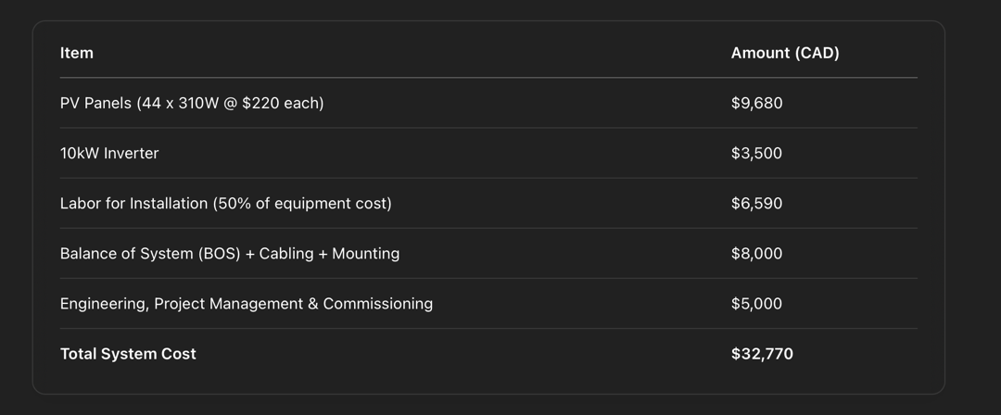

Annual Savings and Payback:
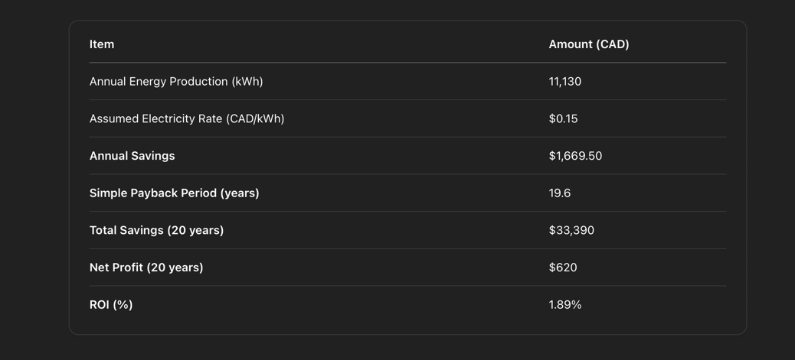
The financial analysis shows that while the system's payback period closely aligns with its 20-year lifespan, it provides a positive return over the long term. The ROI of 1.89% over 20 years demonstrates that the project is a feasible and low-risk investment. Additionally, factors such as potential incentives, rising electricity prices, and environmental benefits could enhance the financial performance.

11. Comparison with One-Axis Tracker System
To evaluate the feasibility of enhancing energy yield through a one-axis tracking system, a comparison was made against the fixed-tilt PV system installed at King Khalid International Airport.
Assumptions:
- Tracker system cost: $20,000 CAD (additional to base system)
- Tracker adjusts 4 times per year to follow seasonal sun angles
- Same PV panel and inverter configuration
- Increased energy yield: ~15–20% (based on industry standards and Riyadh’s solar profile)

Energy Production Comparison:

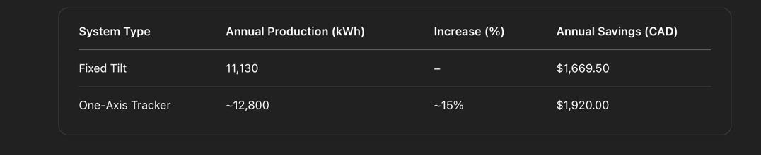
A one-axis tracker increases energy output by ~15%, raising annual savings by $250.50. However, the additional $20,000 CAD cost results in a payback period of nearly 80 years—well beyond the system's 20-year lifespan. Given this long return period, the tracker system is not financially viable and is therefore not recommended for implementation in this project.

B. Summary of Deliverables
The following key components were completed as part of this 10 kW solar PV system design project:
- Selection of a Suitable Site:
King Khalid International Airport in Riyadh was chosen for its high solar potential and open rooftop space.
- Site Capability Analysis:
RETScreen was used to evaluate solar insolation and energy generation potential, confirming strong year-round performance.
- Solar Pathfinder Analysis and Photograph:
Solar path charts and HelioScope shading reports verified minimal obstruction and optimal solar exposure.
- Panel and Inverter Selection:
Three options were analyzed. JA Solar 310W panels and Huawei 10kW inverter were selected for efficiency and compatibility.
- Module and String Layout:
Modules were arranged in landscape orientation with proper spacing and setback for maximum efficiency and safety.
- DC Design and Block Diagram:
HelioScope was used to simulate string configurations, voltage compliance, and layout per Canadian Electrical Code.
- AC Design and Single Line Diagram (SLD):
Wiring from inverter to service panel was designed with appropriate protection and component ratings over a 200 ft feeder.
- Financial Analysis:
The system was found to be marginally profitable with a 19.6-year payback. One-axis tracker was analyzed but deemed not viable.

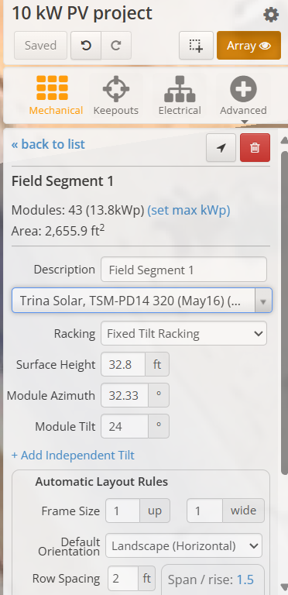
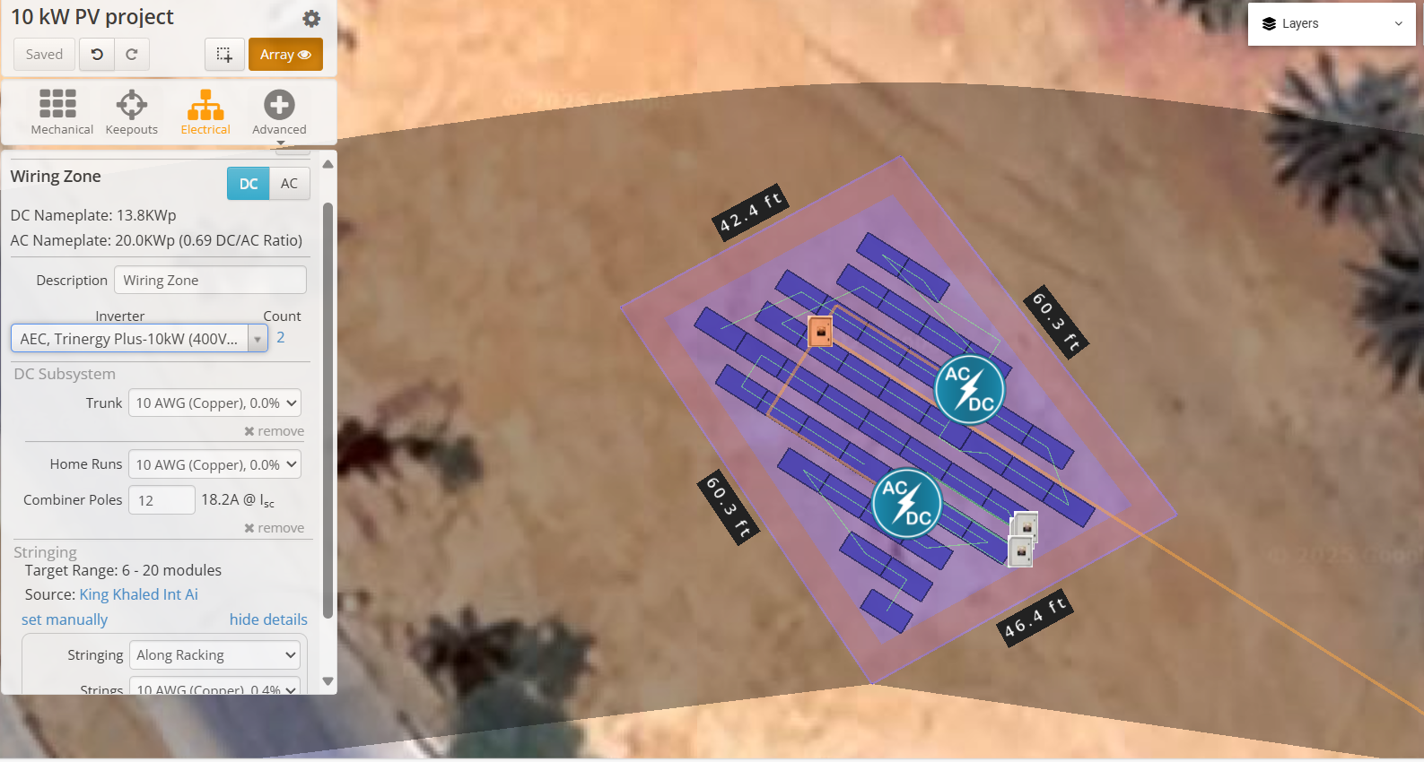
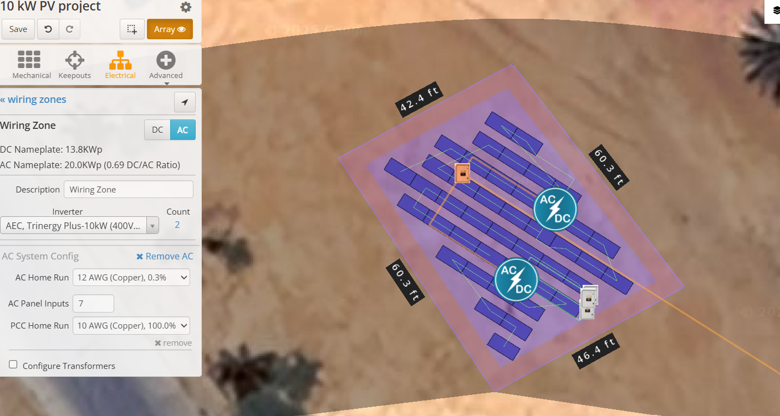
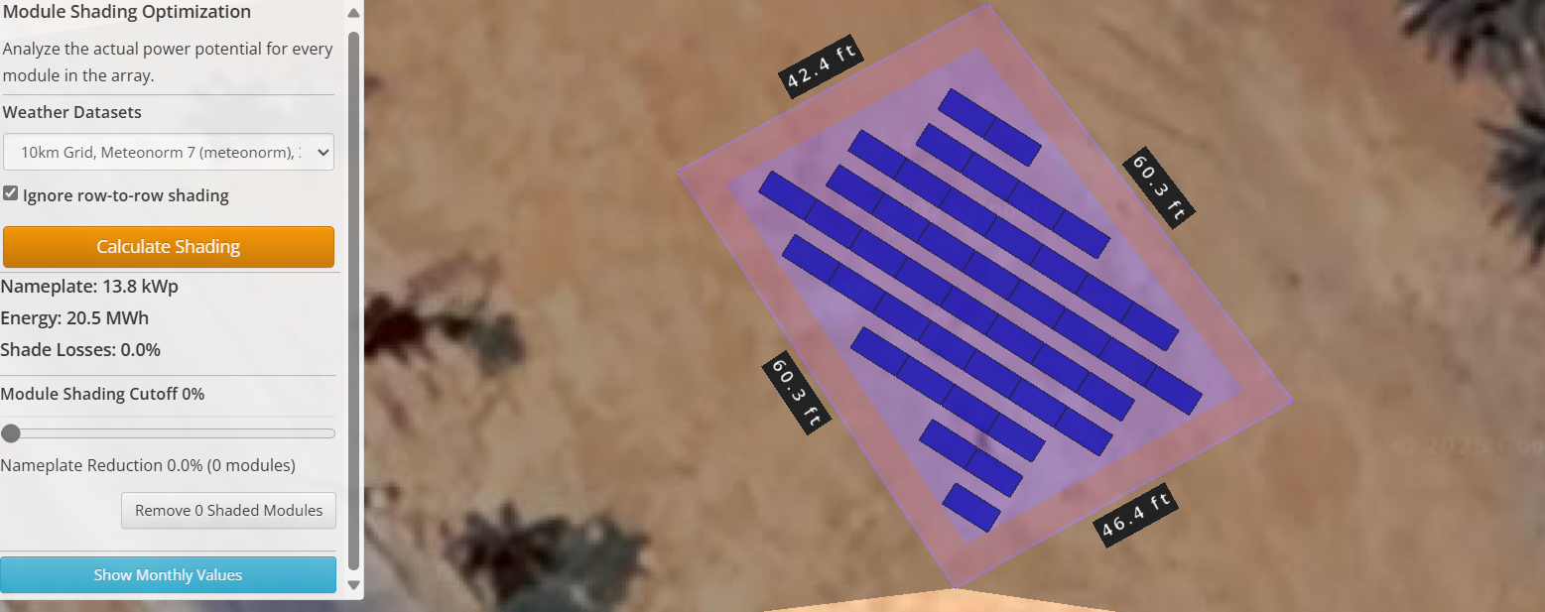
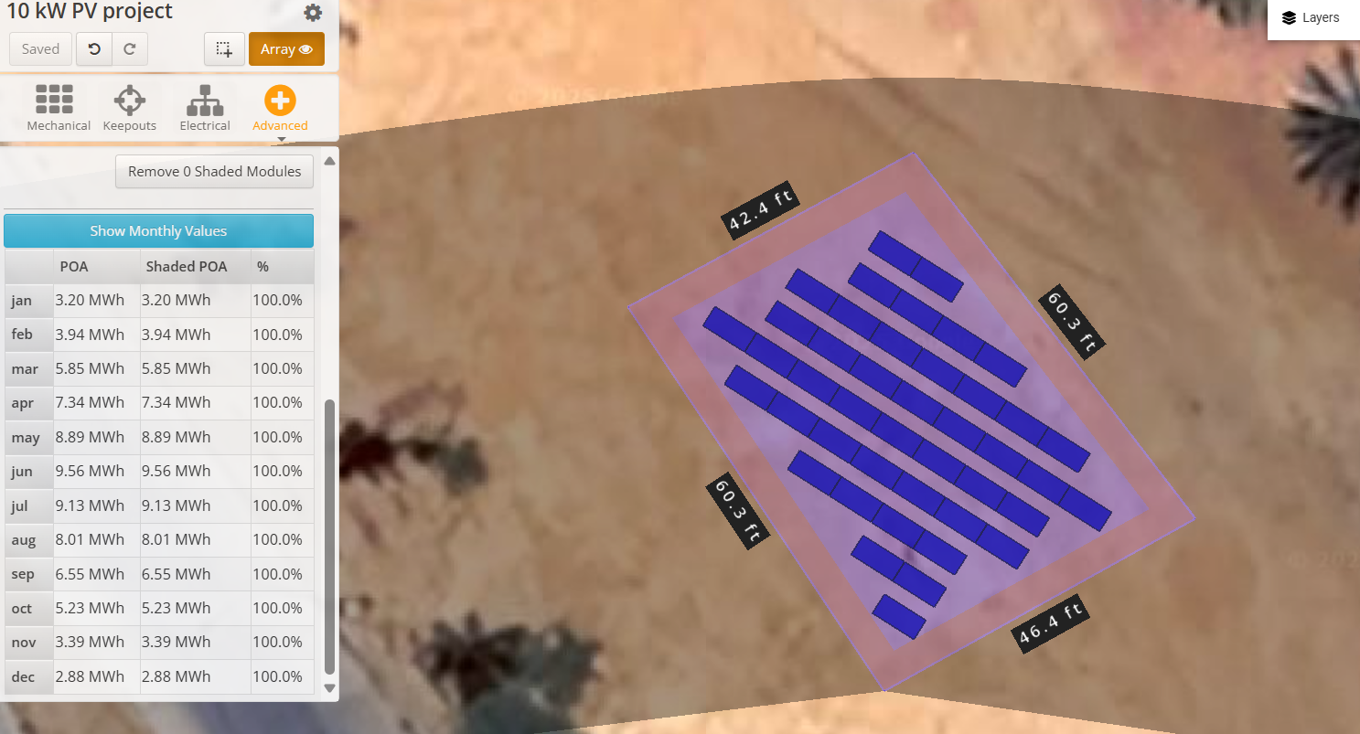

Whether conditions
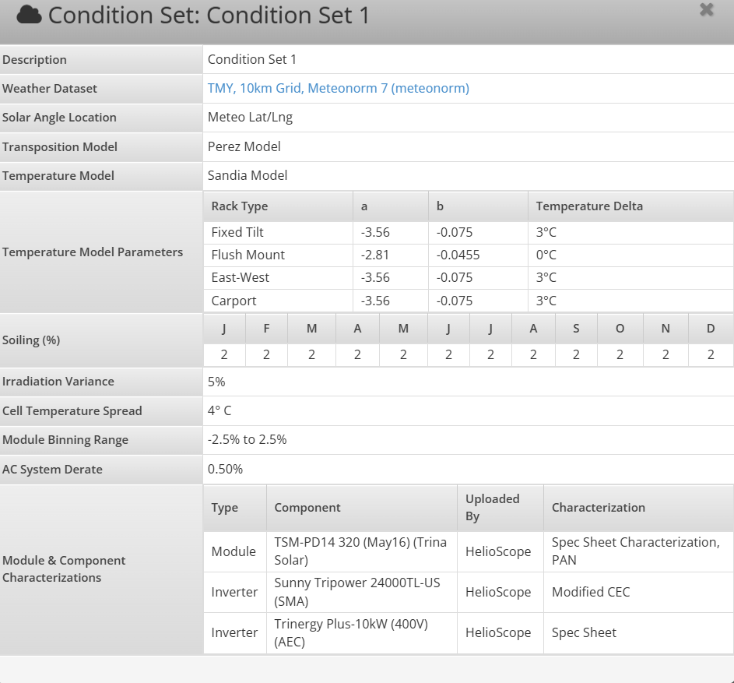

Moudule
